Logbook Week 1
January 13, 2026

My CAPSTONE group members are:
-Jacob Kwan
-Jamie Williams

On this first week we brainstormed ideas for the project. Here is some of what we brainstormed:

Final Ideas for Consideration:
- Robotic arm that can create paintings
- Robotic arm that makes you a cup of coffee
- Wheeled robot:
  - For smog/air purification
  - Follows you around to deliver/carry stuff to workstations
  - Search and rescue robot
  - Minefield clearer bomb disposal robot
  - Rover that collects data and samples
- Submarine robot that swims around and retrieves objects
- Automated sushi rolling assembly line

We ultimately chose the sushi assembly line as it is a fun idea and will showcase our automation skills in manufacturing. This project will utilize a conveyor or dial table for different stations for the “steps” of making the sushi.

We are also waiting to see if we will have the UR robot stored in the back of the room available for the project:

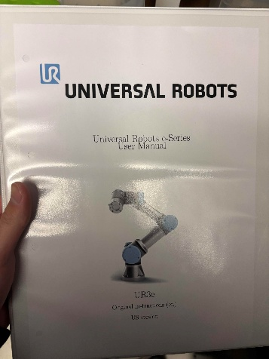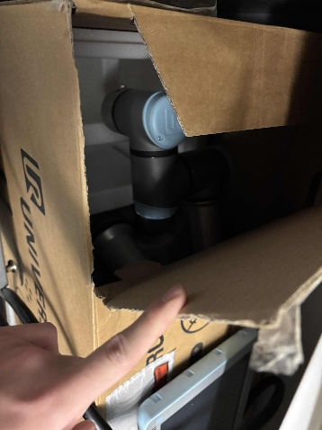

Next we started the rough outline for the assembly line steps.

Sushi making Steps:
- Dispensing the seaweed*
- Dispensing the rice onto the seaweed and making sure it’s flat*
- Laying the roll ingredients onto the sheet
- Roll the entire tightly sheet around itself
- Slice the roll into segments
- Place the pieces onto a plate
- Move the plate onto the conveyor belt

Keep in mind this is a rough outline and we are still planning everything.

Resources we are going to use (and things we must set up in the upcoming weeks):

-Project Requirements and Scope
-FSM Diagram – for hardware and software design
-Onshape CAD – for hardware design
-GitHub – for software development
-Google Drive – for project file management
-Text Group Chat – for communication
-OneNote – for collaborative brainstorming and problem-solving

We started the shared Google drive: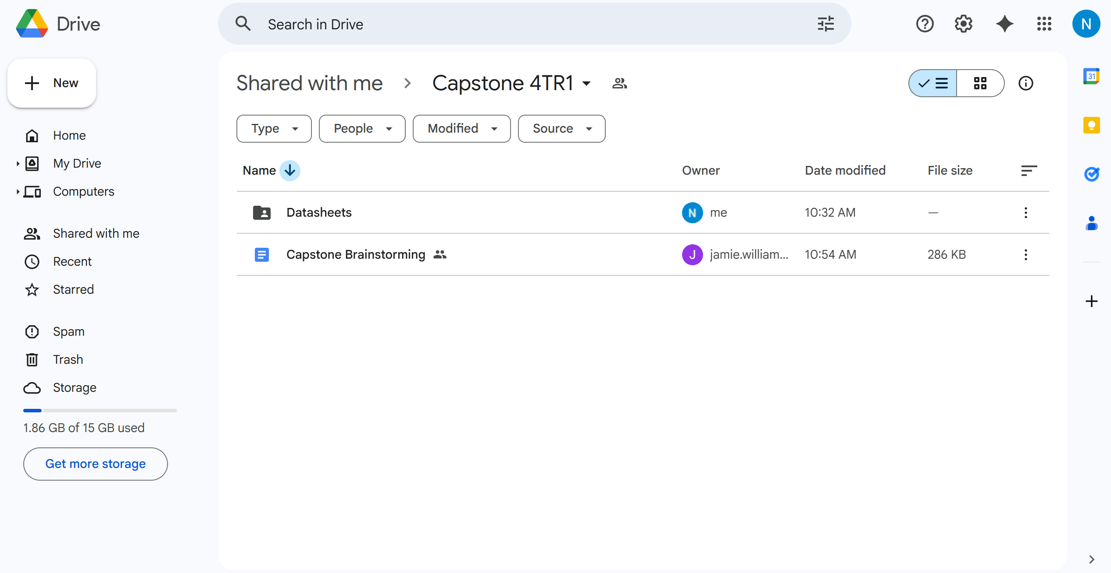

I started a GitHub repo for our code:
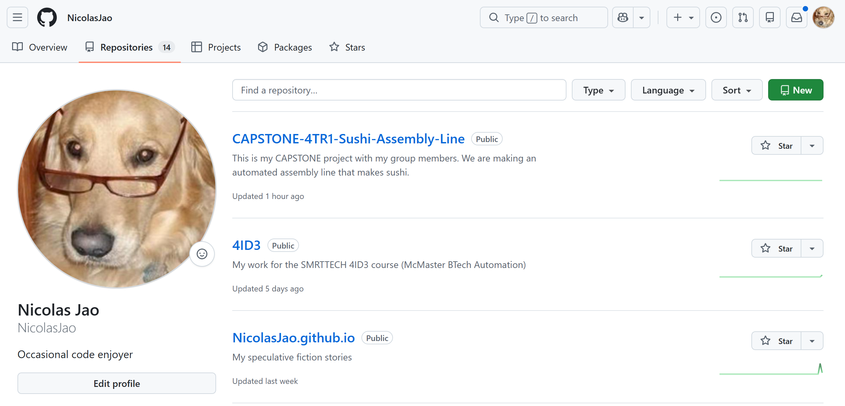

I started the Onshape folder for our CAD designs:
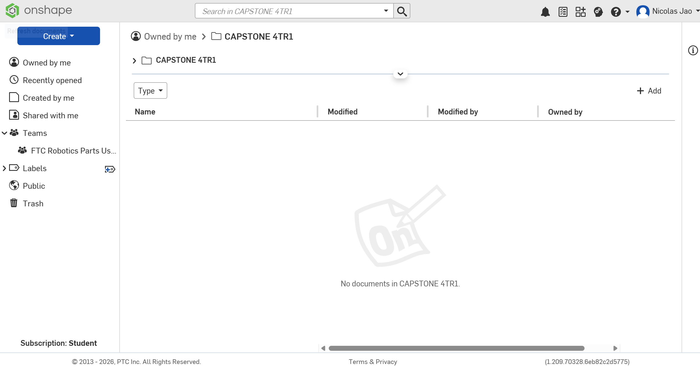

Possible issues we brainstormed we have to solve in the future:
-the mechanisms (principles) for doing each step in the assembly line
-communication interfacing between microcontroller and UR robot (Ethernet/IP to RJ45 cable?)
-how to dispense sticky rice efficiently (will we need an operator?)
-figuring out a dashboard for tasks and scheduling the overall project

